1a)

i) Inverse function = f-1(x) = (x-0.012)/2

0.0077255, 0.031255, 0.125373

ii) 0.005645155242 +0.001596358+0.00058145 = 0.007822963242

iii) Double exposure so x2, 800 ISO so x8, f/8 -> f/16 = 2 stop reduction = /4, ND=2.0 = /10^2

= 0.016

A quick formula:  
X * B / 2^(round(F/2)/round(sqrt(2))) * G/100 / 10^D = V  
where:  
 X = base value  
 B = exposure time  
 F = aperture  
 G = ISO gain  
 D = ND filter  
 V = resultant value under that setup

B)

I) Global tonemapping reduces local contrast which is bad for human visual perception. Local tonemapping preserves edges and details better which means it has better local contrast and mimics human visual perception.

Ii) Global tonemapping happens after local tone mapping, it is the Tone-curve step in the pipeline. It is applied to the base layer obtained after local tone mapping. Colour information is preserved, local details such as edges, contrast? Not sure

Iii) +4 stops => 0.025 * 16 = 0.4

Then 0.4 ^ (1/2.2) = 0.659353291

0.659353291 *255 = 168

C)

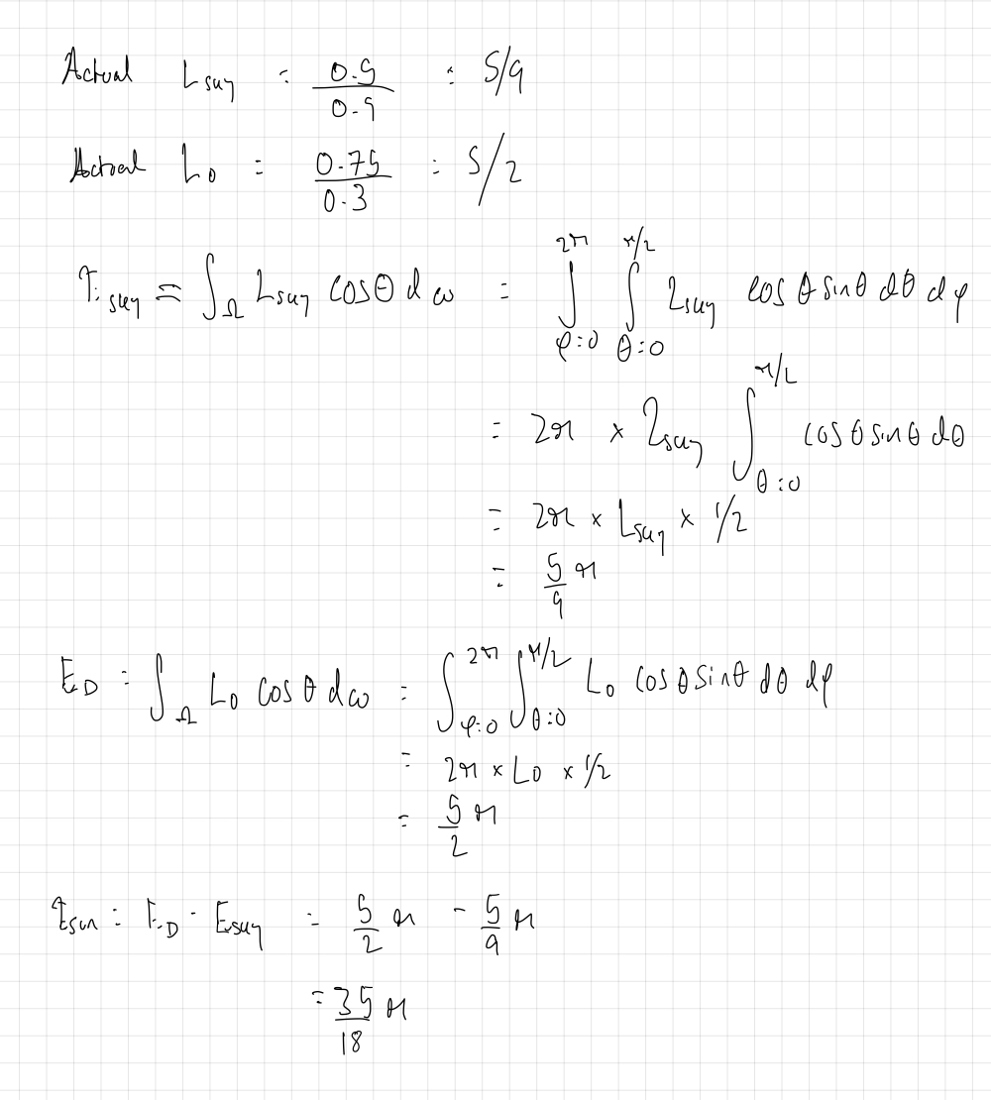

Someone double check it ^ please

D)

i) 4D incident light field and 4d outgoing light field. In the light field we have 2d for angles(spherical coords) and 2d for position. We can simplify this to 6D by getting rid of positional dependence of incoming light and assume that light comes from infinitely far away. And then simplify this further to 4D by fixing the viewpoint position to a single position which means you lose the angular dependence of the outgoing lightfield.

Ii)   
C = camera vector, representing image captured by a camera. Each entry corresponds to a single pixel in the image, should it be flattened  
L = projector vector, representing projected pattern by a projector. Each entry corresponds to a binary value of whether that pixel in a projector I turned on or not, should it be flattened.  
T = light transport matrix, representing how much light from each pixel in L arrives at C, after reflection and refraction etc. Each column is the image seen in response to a specific lighting condition in L

Iii) Camera has 25Megapixel resolution so 5000x5000. Microlens is 10x10? So viewing plane (u,v) is also 10x10. 5000/10 = 500 so 500x500 focal (s,t) plane?

a)

i) <https://sakibsaikia.github.io/graphics/2019/09/10/Deriving-Lambertian-BRDF-From-First-Principles.html> gives an excellent overview of how to do this question, with reasoning.

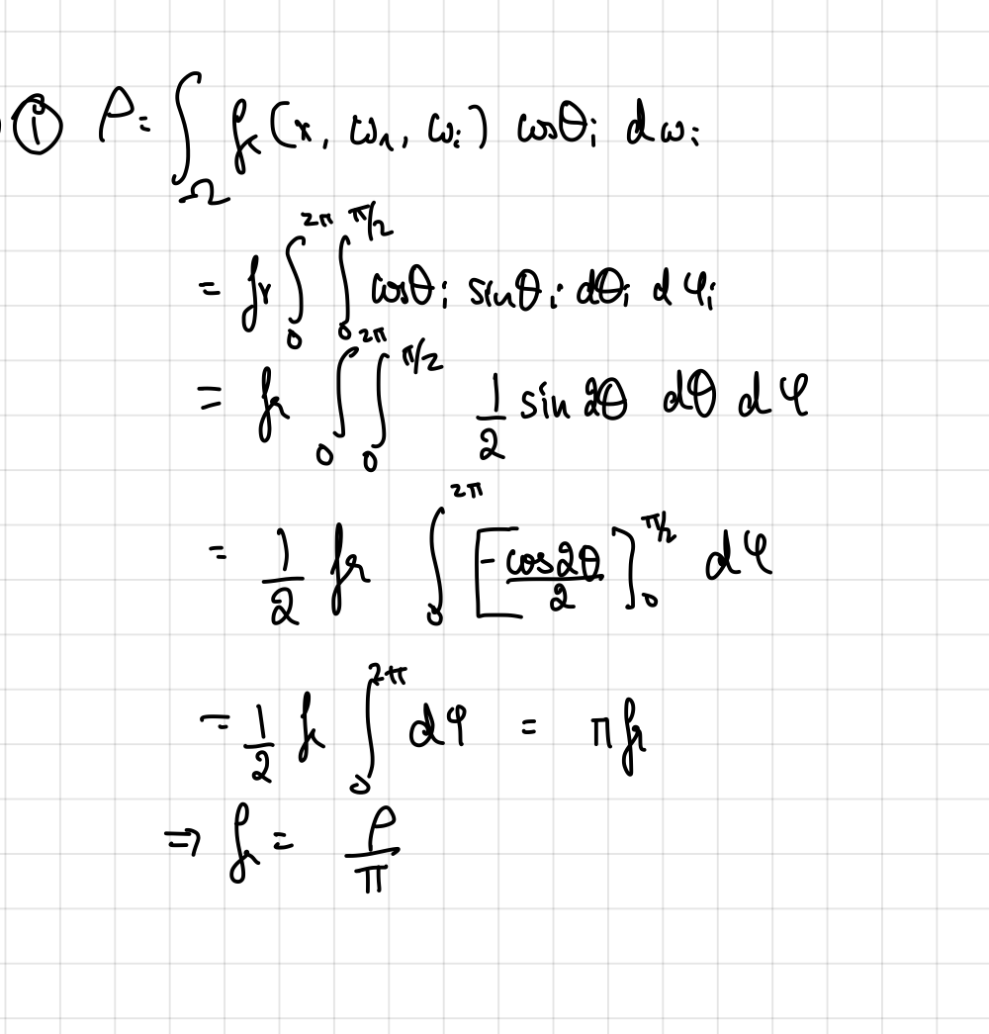

Ii)

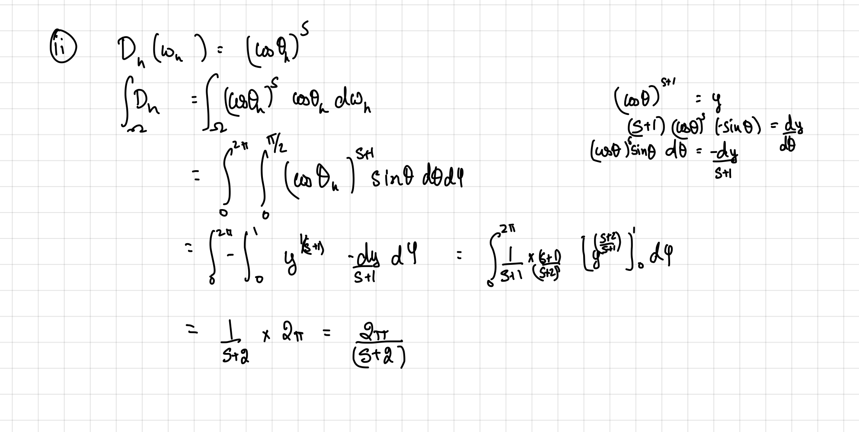We want the integral of Dh to be 1. (By law of conservation of energy, a distribution cannot distribute more energy than it receives). So we must introduce a normalization term, such that 2pi/(s+2) N = 1, thus N = s+2/2pi, we mut normalize by s+2/2pi.

Use this equation to reconstruct wr:

Wi= 2(wh.wr)wh – wr

During sampling, we can then sample with distribution on wr,

P(wr) = p(wh)/4(wh.wr)

b) I) Because it is isotropic there is only variation in the omega_d direction but not in the omega_h direction. This allows for a reparameterisation so that the specular is symmetric about the half vector and so the BRDF matrix can simplify into a 1 rank matrix. This allows for non-lienar sampling where we only need to sample around wh, thus reducing the number of measurements needed.

In MERL, reciprocity is exploited so that we only need to store from 0-180 as reflection will be the same from 180-360 for phi. So we only need to measure 180 instead of 360 measurements.

ii) You have a zone of measurement on a mirrored dome. Then you take the SH basis functions and modify them such that you have orthonormal basis functions defined over this zone. Then you illuminate with the basis illumination Z_k which computes the integral optically. It is recording the coefficient of the zonal basis function of the BRDF.

During rendering you load the coefficients Z_ks and reconstruct the BRDF by doing a sum of products of the coefficients and the basis functions.

The advantage is that there is much less noise in the measurements and there are no missing measurements because you can use the basis functions to evaluate at any angle.

C)

I) cdf = (x^4)/3

Inverse = 4th root(3x)

ii) Lecture 9, slide 19 gives you equations for phi and theta

Phi_h = -1.2394 rad = -71 degrees

Theta_h = 0.82752 rad = 47.4 degrees

D) I think this question is a trick question; light never exits the medium.

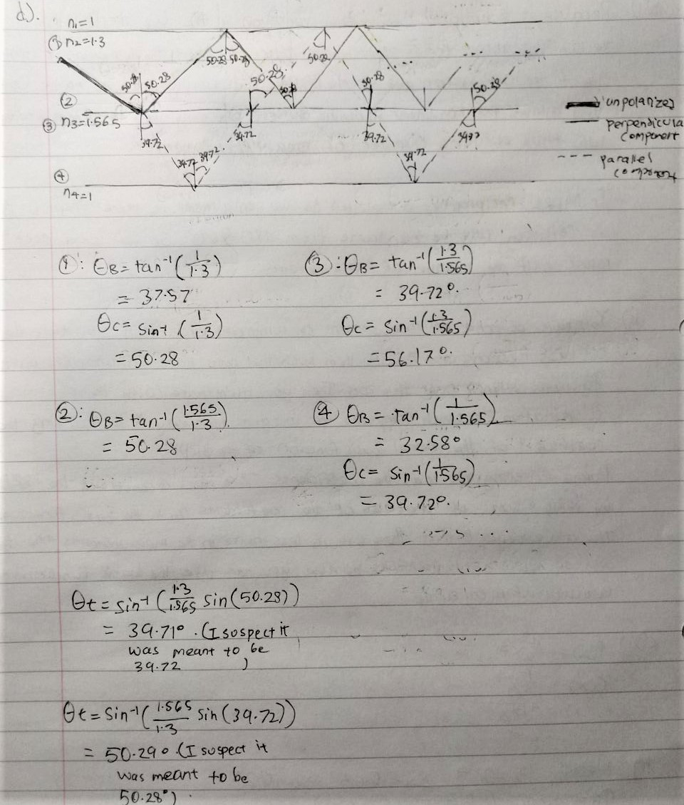

3)

a)

i) Target distribution should represent the distribution of light throughout the scene, whether it be incoming light from the environment or reflected light defined by the BRDF. The problem is the target distribution is complicated and unknown, composed of several different distributions, and thus difficult to sample directly from.

ii) Proposal distribution could be the EM or BRDF distribution. The problem is if the distributions are high frequency and very different from one another, sampling from just one is not an accurate representation of the target distribution. We will miss lighting information from the other distribution.

iii) If you only sample from the illumination distribution or only from BRDF, then you end up with noise. You can use MIS to fix this because it samples both distributions. BIS also fixes this by sampling from an ideal distribution that is an amalgamation of both distributions.

b)

i) Row pdf = 0.65, 0.35

Row cdf = 0.65, 1.0

So for u1 = 0.7 => row 2

Then pdf of the cols in this row = 15/35, 20/35

Cdf = 15/35, 1

u2 = 0.4 => col 1

So r2, c1 => 15

Ii)

u1 = 0.3 => row 1

Pdf = 25/65, 40/65

Cdf = 25/65, 1

u2 = 0.65 => col 2

So r1, c2 => 40

Iii) Not sure, please someone who did this part of the CW give input

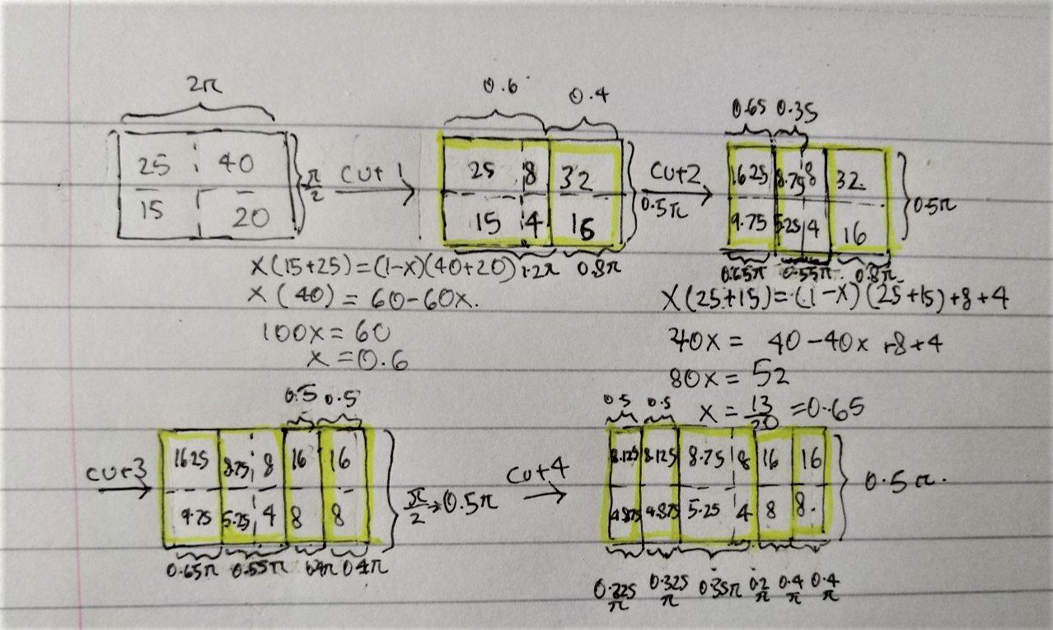

C)

I) The idea is that indirect lighting generally changes slowly compared to direct lighting. This is especially true for diffuse surfaces. We can compute irradiance at sparse points, cache the values and interpolate for the points in between.

Ii) no longer examinable? Think so

Iii) 500 * 0.75/pi * 0.25/(pi * 0.2^2) = 237.4715242

Local photon density is much higher for caustics than for indirect illumination

D)

i) Light fog is an optically thin media and when light travels through it it will hit a particle in the fog every now and then. This results in single scattering. In dense fog, there’s many more particles so light will scatter many more times resulting in multiple scattering.

ii) We have a multilayer diffusion model for skin which can better model the layers of skin such as the dermis and epidermis. These layers can’t be approximated as a homogenous semi-infinite layer like in the case of wax or marble.

TODO add more here

Iii)

R_12 = 0.25 + (0.9 * 0.35 * 0.9)/(1 – 0.35 * 0.25) = 0.56068

T_12 = (0.9 * 0.75) / (1 – 0.35 * 0.25) = 0.73973

iv)   
Primary highlight: anisotropic surface reflection  
Secondary highlight: single scattering

Dark hair: single scattering  
Light hair: multiple scattering